Chapter 8

MOST EFFICIENT TECHNOLOGY

8.1 Characteristics of a highly efficient propeller type
small wind turbine with a diffuser :

We evaluated a wind turbine fitted with a diffuser with the aim of improving the Turbine’s output power characteristics. We used thermo hydrodynamic analysis software to simulate the effect of the diffuser parameters on the wind speed, and evaluated the turbine

8.2 Simulation results

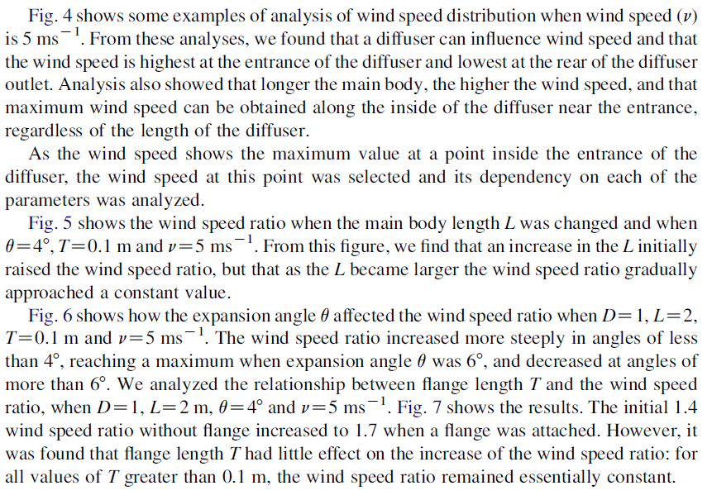
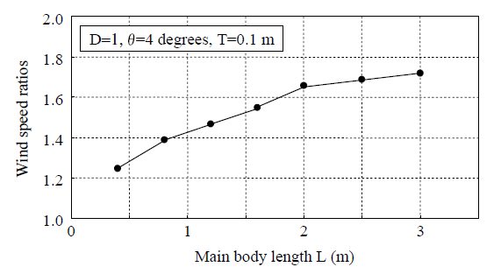

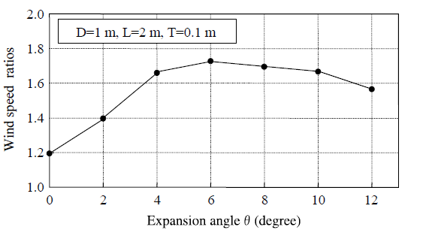

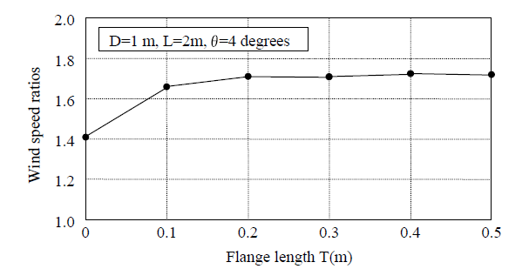

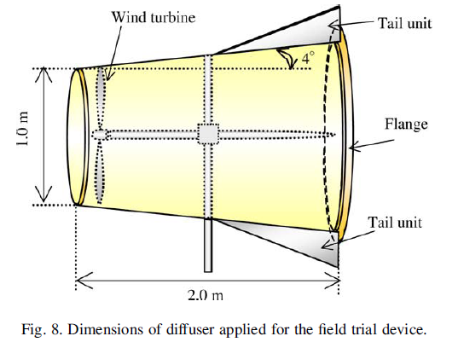

MOST EFFICIENT TECHNOLOGY

8.3 WindTamer:

Patented WindTamer technology produces more than
double the power of traditional wind turbines for a faster
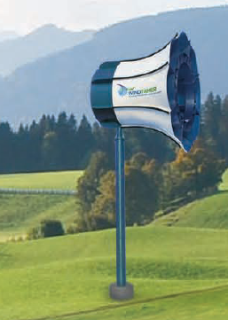return on investment.

WindTamer turbines use a patented diffuser system to
separate the wind into three cooperative forces. First, the
wind pushes the blades to start rotating. Then, the diffuser
system separates the air, creating two vacuums — one
behind the blades and another behind the turbine. The
vacuums pull the air through, turning the rotors faster and
generating more power — more than double the energy
of conventional turbines.

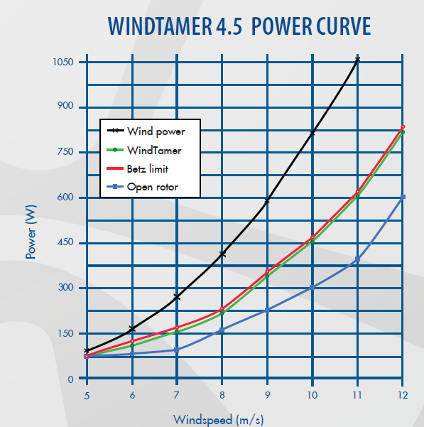
Traditional three-blade turbines need to furl in high winds to avoid damage to the long blades.
The shorter blades on WindTamer turbines aren’t damaged in high winds.
In fact, the diffuser system augments the high winds, resulting in higher energy production for a faster return on investment.

8.3.1 Clean energy with fewer concerns
Most people can agree on the benefits of clean energy.
It’s not only good for the environment, it also reduces energy
costs. Plus, government incentives make the initial investment more affordable. Wind power often faces opposition, however, because of several issues including danger to birds, noise and appearance. WindTamer turbines
answer all these.

8.3.2 Silent and vibration free
The high tip speed and vibration of conventional turbine blades cause a hum that has caused complaints in many communities. WindTamer turbines operate quietly and without vibration. The largest WindTamer turbine rotating at high speeds is about as loud as a refrigerator.

8.3.3 Safe for birds — and people

On traditional three-blade turbines, when the wind speed is only about 15 miles per hour, their blade tips travel at a speed of over 200 miles per hour. Thousands
of birds have been killed when they fly in the path of those spinning blades. Because the blades of WindTamer turbines are housed, birds do not fly in their path.
Conventional turbines also can pose dangers to people.
In high winds, their blades can disintegrate or detach
from the rotor and be thrown a long distance. In addition,
ice can form on the blades and be thrown off. Because
the WindTamer rotors are housed, these situations are
not an issue

.
8.3.4 MINIMAL MAINTENANCE
WindTamer turbines require little routine maintenance and have few
moving parts. Plus, key components are housed, protecting them from the elements and U/V rays.

8.3.5 EASY ACCESS
Service and repairs are much simpler on WindTamer turbines than larger
turbines. Because the turbines are closer to the ground, they do not require cranes to access the rotors.

